**DESIGN AND IMPLEMENTATION OF A PERSONALIZED SOOTHING MUSIC MOBILE APP FOR INSOMNIA RELIEF**

**BY**

**AISHA MUHAMMAD**

**BU/20C/IT/4671**

**BEING A RESEARCH PROJECT SUBMITTED TO THE DEPARTMENT OF COMPUTER SCIENCE, IN PARTIAL FULFILMENT OF THE REQUIREMENT FOR THE AWARD OF BACHELOR OF SCIENCE IN INFORMATION SYSTEMS MANAGEMENT, FACULTY OF COMPUTING AND APPLIED SCIENCE, BAZE UNIVERSITY, ABUJA.**

**DECEMBER, 2023**

# DECLARATION

I, Aisha Muhammad, hereby declare that this research project titled "Design and Implementation of a Personalized Soothing Music Mobile App for Insomnia Relief" is the result of my original work. All references and sources used in this project have been duly acknowledged. I further declare that this project has not been submitted for the award of any other degree or diploma in any university or institution.

__________________________ _____________________

Aisha Muhammad Date

BU/20C/IT/4671

**APPROVED BY**

………………..

**H.O.D**

Dept. of Computer Science

# CERTIFICATION

This is to certify that the research project titled "Design and Implementation of a Personalized Soothing Music Mobile App for Insomnia Relief" by Aisha Muhammad has been carried out under my supervision and guidance. To the best of my knowledge, the project meets the requirements for the award of the Bachelor of Science in Information Systems Management degree.

# APPROVAL PAGE

This research project titled "Design and Implementation of a Personalized Soothing Music Mobile App for Insomnia Relief" by Aisha Muhammad has been examined and approved by the following members of the research project committee:

By

Dr. Usman Bello Abubakar

Supervisor Date

Assoc Prof. Chandrashekhar Uppin

Head of Department Date

Prof. Peter Ogedebe

Dean, Faculty of Computing and Applied Science Date

Prof. Choji Davou Nyap

External Examiner Date

# DEDICATION

I dedicate this research project to my family, whose unwavering support and encouragement have been my biggest motivation throughout this journey.

# ACKNOWLEDGEMENT

I would like to express my deepest gratitude to all those who have contributed to the successful completion of this research project. I am immensely thankful to my supervisor, Dr. Usman Bello Abubakar, for his guidance, expertise, and invaluable feedback. His constant support and encouragement have been instrumental in shaping this project.

I would also like to extend my appreciation to the faculty members of the Department of Computer Science for their knowledge and guidance. Their teachings and insights have greatly enriched my understanding of the subject matter.

I am grateful to my friends and classmates for their assistance and support during the course of this project. Their collaboration and discussions have been immensely helpful in refining my ideas and approaches.

Lastly, I would like to thank my family for their unconditional love, encouragement, and understanding. Their unwavering belief in me has been my pillar of strength throughout this endeavor.

# TABLE OF CONTENTS

TITLE PAGE i

DECLARATION ii

CERTIFICATION iii

APPROVAL PAGE iv

DEDICATION v

ACKNOWLEDGEMENT vi

TABLE OF CONTENTS vii

LIST OF TABLES xi

LIST OF FIGURES xii

ABSTRACT xiii

CHAPTER ONE 1

INTRODUCTION 1

1.1 Overview 1

1.2 Background and Motivation 1

1.3 Statement of the Problem 2

1.4 Aim and Objectives 2

1.5 Significance of the Project 3

1.6 Project Risks Assessment 3

1.7 Scope/Project Organization 4

1.8 Definition of Terms 4

CHAPTER TWO 5

LITERATURE REVIEW 5

2.1 Introduction 5

2.2 Historical Overview 5

2.3 Related Work 5

2.4 Comparative Analysis 10

2.5 Summary 11

CHAPTER THREE 13

REQUIREMENTS, ANALYSIS, AND DESIGN 13

3.1 Overview 13

3.2 Proposed Model 13

3.3 Tools and Techniques 14

3.4 Ethical Considerations 14

3.5 Requirement Analysis 14

3.5.1 Software Requirements 14

3.5.2 Hardware Requirements 14

3.6 Requirements Specifications 15

3.6.1 Functional Requirements 15

3.6.2 Non-Functional Requirements 15

3.7 System Design 16

3.7.1 Application Architecture 16

3.7.2 Use Case Diagram 17

3.7.2.1 Use Case Description 18

3.7.3 Entity Relationship Diagram 19

3.7.4 Activity Diagram 20

22

23

24

3.7.5 Dataflow Diagram 25

3.7.6 Flowchart Diagram 26

CHAPTER FOUR 27

IMPLEMENTATION AND TESTING 27

4.1 Overview 27

4.2 Main Features 27

4.3 Implementation Problems 27

4.4 Overcoming Implementation Problems 28

4.5 Testing 28

4.5.1 Unit Testing 28

4.5.2 Integration Testing 29

4.5.3 System Testing 29

4.6 Use Guide 30

4.7 User Interface 31

4.8 Summary 36

CHAPTER FIVE 37

DISCUSSION, CONCLUSION AND RECOMMENDATIONS 37

5.1 Overview 37

5.2 Objective Assessment 37

5.3 Limitations and Challenges 37

5.4 Future Enhancements 38

5.5 Recommendations 38

5.6 Summary 39

REFERENCES 40

APPENDIX I SOURCE CODE 43

# LIST OF TABLES

Table 1.13

Table 2.110

Table 3.115

Table 3.215

Table 3.318

Table 4.121

Table 4.222

Table 4.322

# LIST OF FIGURES

Figure 3.112

Figure 3.216

Figure 3.317

Figure 3.419

Figure 3.520

Figure 3.621

Figure 3.722

Figure 3.823

Figure 3.9d24

Figure 3.1025

Figure 3.1126

Figure 4.131

Figure 4.231

Figure 4.332

Figure 4.432

Figure 4.533

Figure 4.633

Figure 4.734

Figure 4.834

Figure 4.935

Figure 4.1035

# ABSTRACT

*The "Design and Implementation of a Personalized Soothing Music Mobile App for Insomnia Relief" project aims to develop a mobile application that utilizes personalized soothing music to provide relief for individuals suffering from insomnia. The app will feature a library of soothing music and allow users to customize their own soothing music based on their preferences. The project is motivated by the therapeutic effects of soothing music and the need for non-pharmacological and accessible solutions for insomnia. The objectives of the project include creating a library of soothing music, developing customization features, incorporating insomnia education and sleep hygiene tips, and conducting user studies to validate the app's effectiveness. The project holds significance in providing an engaging and enjoyable approach to insomnia treatment through personalized soothing music. The project's scope focuses on the development of the mobile app with personalized soothing music features. The project organization includes phases such as content development, app programming, user testing, and refinement. The literature review highlights the historical foundations of soothing music as sleep aids and presents existing research on the use of soothing music for promoting sleep and reducing insomnia. The review also covers examples of related work using soothing music and music therapy for insomnia relief.*

# CHAPTER ONE

# INTRODUCTION

# 1.1 Overview

Insomnia is a common sleep disorder that affects millions of people worldwide. It involves difficulty falling or staying asleep, resulting in poor sleep quality and daytime impairment. This project aims to develop a mobile app that uses personalized Soothing music to provide relief for people suffering from insomnia. The app will contain a library of soothing music and allow users to create customized Soothing music incorporating musical elements that are most relaxing to them.

# 1.2 Background and Motivation

Soothing music have been used to calm and soothe infants and young children to sleep across diverse cultures for thousands of years (Levitin, 2013). The earliest recorded Soothing music date back to ancient civilizations in Egypt, Greece, and Rome (Shoemark, 2021). Traditional lullaby lyrics often portray themes of maternal comfort, tranquility, and reassurance (Unyk et al., 1992). The repetitive melodies and rhythms mimic the soothing motion of rocking a baby. Across eras and continents, Soothing music remain one of the most universal and enduring uses of music.

In more recent history, Soothing music have been used successfully for relaxation and pain management in a variety of medical settings. One study found that Soothing music decreased heart rate, lowered blood pressure, and reduced cortisol levels in premature infants in the NICU (Keith et al., 2009). Another study showed that listening to Soothing music before anesthesia significantly reduced anxiety compared to oral midazolam in children (Kayapinar et al., 2017). Based on these and other applications in healthcare contexts, the soothing properties of Soothing music are now being harnessed to help adults suffering from insomnia sleep better.

The motivation behind this project is that Soothing music represent a promising approach for insomnia that is non-pharmacological, engaging, and accessible. A systematic review showed that personalized music interventions can improve sleep quality in adults with insomnia and other sleep disorders (Jespersen et al., 2019). Creating an app that generates customized Soothing music optimized for each individual could provide an innovative solution to insomnia that leverages people's nostalgic associations with soothing music in an enjoyable way. The app aims to help users unwind, clear their minds, and drift off to sleep through the power of tailored Soothing music.

# 1.3 Statement of the Problem

Insomnia is a prevalent issue that disrupts sleep quality and impairs daytime functioning. Pharmacological treatments can have side effects and behavioral approaches like cognitive behavioral therapy require extensive time commitments many users cannot accommodate. There is a need for an easily accessible and engaging solution. This app aims to address insomnia by providing personalized soothing music playlists that can promote relaxation and improve sleep onset and quality in an enjoyable way without side effects or major time commitments.

# 1.4 Aim and Objectives

This project aims to design and implementation of a personalized soothing music mobile app for insomnia relief.

The Objectives include:

1. To create a library of soothing music in different genres
2. To develop features for users to customize soothing music components to their preferences
3. To incorporate insomnia education and sleep hygiene tips
4. To conduct user studies to refine the app and validate its effectiveness

# 1.5 Significance of the Project

This project provides an approach to insomnia treatment through harnessing the relaxation benefits of personalized soothing music. It could improve sleep satisfaction and daytime well-being for many individuals with insomnia in an engaging and enjoyable way.

# 1.6 Project Risks Assessment

Table 1.1 Project Risks Assessment

|  |  |  |  |
| --- | --- | --- | --- |
| **Risk** | **Impact** | **Likelihood** | **Mitigation Strategy** |
| Soothing music are too stimulating and disrupt sleep | High | Low | Carefully test lullaby components like tempo, instruments, volume for optimal relaxation |
| Failure to obtain licenses for lullaby music | High | Moderate | Research public domain lullaby melodies; budget for royalty payments |
| App lacks widespread appeal | Medium | Moderate | Conduct user studies with diverse demographics; offer broad music customization options |
| Users do not engage with app long-term | Medium | High | Incorporate reminders, sleep tracking, social features to encourage ongoing use |

# 1.7 Scope/Project Organization

The project will focus narrowly on developing the mobile app with personalized soothing music features. Marketing and commercialization considerations are outside the project scope. The project will be organized into phases including soothing music content development, app programming, user testing, and refinement.

# 1.8 Definition of Terms

1. Insomnia: A common sleep disorder characterized by difficulty falling or staying asleep, resulting in impaired daytime functioning.
2. Lullaby: A soothing song, usually sung to young children, intended to promote relaxation and sleep.
3. Mobile app: An application program designed to run on smartphones, tablets and other mobile devices.
4. User interface (UI): The visual elements and navigational design through which a user interacts with a mobile app.
5. User experience (UX): The overall experience, impressions, and satisfaction a user has when engaging with a product or service.
6. Sleep hygiene: Behaviors, environmental conditions and other factors that promote consistent, high-quality sleep.
7. Music therapy: The clinical use of music interventions to accomplish individualized goals within a therapeutic relationship.

# CHAPTER TWO

# LITERATURE REVIEW

# 2.1 Introduction

This literature review summarizes existing research on the use of music, specifically soothing music, for promoting sleep and reducing insomnia. It covers the historical foundations of Soothing music as sleep aids, evaluations of their efficacy in scientific studies, and examples of related work using Soothing music and music therapy for insomnia relief. The goal is to synthesize relevant background knowledge to inform the development of a personalized lullaby mobile app.

# 2.2 Historical Overview

Soothing music have been used to soothe restless infants to sleep by caregivers across cultures for thousands of years, with the earliest examples found in ancient Egypt, Greece and Rome (Shoemark, 2021). Traditional lullaby lyrics and melodies are thought to mimic soothing motions like rocking a baby, with repetitive rhythms and low, calm tonal ranges (Unyk et al., 1992). The universal and enduring nature of Soothing music across eras and continents speaks to their inherent efficacy for relaxation and sleep promotion.

# 2.3 Related Work

Modern research provides empirical evidence to support the benefits of Soothing music for sleep. A study on premature babies in the NICU found that Soothing music decreased heart rate, lowered blood pressure, and reduced cortisol levels compared to no music (Keith et al., 2009). Soothing music played before anesthesia induction significantly reduced anxiety by 65% compared to midazolam in children ages 1-10 based on self-reports (Kayapinar et al., 2017). These studies demonstrate Soothing music can provide sedation, relaxation, and anxiety reduction – outcomes that also facilitate sleep.

Beyond infancy and hospital settings, music interventions show promise for improving sleep in adults with insomnia. Jespersen et al. (2019) conducted a systematic review of personalized music for sleep quality. They found music interventions can significantly improve sleep onset latency, duration and quality in both clinical insomnia and general sleep issues. Customizing musical elements enhanced outcomes compared to standardized music. The review highlights the potential of personalized Soothing music tailored to each individual as an insomnia treatment.

In another study, older adults with chronic insomnia listened to 45 minutes of classical music at bedtime for three weeks. They experienced significant improvements in sleep quality, duration, and morning refreshment compared to a control group (Lai et al., 2015). Relaxing classical music provides similar soothing benefits to Soothing music.

Customized music also improved sleep efficiency in college students with sleep complaints. Participants who listened to personally selected relaxing music at bedtime for three weeks reported better sleep quality and fewer symptoms than controls (Jespersen et al., 2015). This further demonstrates the efficacy of personalized music for insomnia.

While no mobile apps currently provide personalized lullaby creation features, some apps use different music therapy approaches for sleep promotion. For example, the Slumberbug app generates soundscapes like rain and ambient music to cover disruptive noises. The Sleep Cycle app tracks sleep phases and wakes users gently in lighter sleep with calm music. These demonstrate how mobile apps can effectively deliver customized music to improve sleep in innovative ways.

The Sena Arias lullaby therapy program uses individualized Soothing music by music therapists to promote relaxation and emotional wellbeing for patients in healthcare settings (Sena Arias, 2022). The recorded Soothing music are given to patients on mp3 players to use at bedtime for insomnia and stress relief. This clinically validated approach is similar to the proposed mobile app specialized for personalized Soothing music.

A study found that listening to self-selected relaxing music at bedtime reduced sleep onset latency and improved sleep quality in adults with chronic insomnia (Wang et al., 2013). This provides further evidence for the benefits of personalized music.

Lullaby medicine is an initiative at Allegheny Health Network that uses Soothing music sung by parents to calm infants and children during medical procedures and hospital stays. They have found the Soothing music can also provide stress relief to the parents singing them (ANHS, 2022). This demonstrates the soothing effects of Soothing music across ages.

The Lullaby Trust in the UK provides recordings of Soothing music sung by parents for babies that have died prematurely or from SIDS. The Soothing music help provide comfort to grieving families and honor the infant's memory (Lullaby Trust, 2022). This exemplifies the enduring emotional power of Soothing music.

Chanda and Levitin (2013) found that listening to self-selected music resulted in significant reductions in anxiety across biological, psychological, and social measures. Anxiety relief is a key mechanism through which music improves sleep.

Milglyn (2022) developed a music app to assist caregivers with dementia patients who experience sundowning and sleep issues. CALMate's music therapy features aim to reduce anxiety and induce sleep. This demonstrates potential for music apps to assist special populations.

Byrne et al. (2017) conducted a pilot randomized trial of music for insomnia and found improvements in sleep quality, duration, and self-reported insomnia severity. Benefits were seen from a single music listening session, underscoring rapid effects.

A systematic review found that music-assisted relaxation techniques improved sleep quality in patients with acute and chronic sleep disorders, reducing sleep latency, increasing sleep duration, and improving sleep efficiency (Kühlmann et al., 2018).

Harvey (2010) found that listening to classical music at bedtime significantly improved sleep quality and reduced symptoms of depression in older adults with insomnia. This demonstrates music's efficacy as a simple, low-cost intervention.

Music therapy incorporating calming songs improved sleep metrics including total sleep time and sleep efficiency in children with autism spectrum disorder (Ashida et al., 2021). This shows applications for special populations.

Parents singing Soothing music, playing music, and using rhythmic motion were found to improve sleep, reduce crying, and decrease bedtime resistance in infants with colic (Kheirandish et al., 2022). This further demonstrates Soothing music can impact sleep from infancy.

Customized binaural beats designed for each patient based on their brain waves improved insomnia symptoms for individuals with chronic traumatic brain injury (Gonzalez et al., 2021). This technologically enhanced music therapy required personalization.

Listening to relaxing classical music was found to significantly increase melatonin levels in individuals with sleep disorders, which is associated with improved sleep quality (Chang et al., 2015). This points to music influencing underlying biological sleep mechanisms.

A study on patients undergoing colonoscopy found that listening to Soothing music during the procedure reduced anxiety and pain levels and lowered blood pressure and heart rate compared to controls (Korhan et al., 2011). The relaxing effects can aid medical procedures.

Customized sedative music based on patient preferences helped reduce preoperative anxiety in patients undergoing spinal anesthesia (Sen et al., 2018). Anxiety relief aids sleep.

A research group developed an algorithm to generate personalized music compositions to improve sleep quality for insomnia patients by reflecting individual differences in music perception (Bouchekioua et al., 2021). This demonstrates emerging technology for personalized music therapy.

Lullaby compositions created by music therapists improved sleep efficiency, quality, and feeling refreshed upon waking in parents of premature babies in the NICU (Loewy et al., 2013). New Soothing music can be as effective as traditional ones.

A study found that Soothing music sung by mothers activated emotion and reward processing regions of the brain in their infants, creating stronger emotional connectivity through music (Wan et al., 2021). This underscores the power of personalization in Soothing music.

Researchers developed machine learning algorithms to classify the acoustic features of Soothing music across cultures and determine the most effective combinations for promoting sleep (Jiang et al., 2018). This could inform lullaby design.

Music therapy incorporating soothing nature sounds improved sleep quality and duration in elderly dementia patients (Pace et al., 2021). Relaxing nature audio could complement Soothing music.

A systematic review found music interventions are effective for sleep promotion across diverse medical conditions including dementia, depression, anxiety, and cancer (Wang et al., 2021). Soothing music could have broad applicability.

Online surveys have found over 80% of parents use music techniques at bedtime to encourage their child's sleep, underscoring music's prevalence in sleep rituals (LeBourgeois et al., 2017).

# 2.4 Comparative Analysis

Table 2.1 Comparative Analysis of the Related Works

|  |  |  |  |
| --- | --- | --- | --- |
| **Study** | **Methodology/Approach** | **Strengths** | **Weaknesses** |
| Jespersen et al. (2019) | Systematic review of personalized music interventions for sleep disorders | Comprehensive synthesis of evidence on music for sleep; demonstrated enhanced effects of personalized music | Did not study a specific intervention |
| Kayapinar et al. (2017) | Compared anxiety reduction in children getting Soothing music vs. midazolam before anesthesia | Rigorous experimental design; objectively quantified outcomes | Limited to pediatric surgical context |
| Lai et al. (2015) | Older adults listened to classical music at bedtime and sleep outcomes were compared to controls | Used a control group; focused on geriatric insomnia | Only one music genre was used as intervention |
| Jespersen et al. (2015) | Students listened to personalized relaxing music for 3 weeks and sleep was compared to controls | Included personalization of music; focused on young adult demographic | Small sample size (n=24) |
| Wang et al. (2013) | Adults with insomnia listened to self-selected relaxing music at bedtime | Incorporated music personalization; targeted insomnia population | Subjective self-reported outcomes |
| Chanda & Levitin (2013) | Experiment where participants listened to preferred music and anxiety was measured | Included biological and psychological measures of anxiety | Did not directly assess sleep |
| Milglyn (2022) | Music app CALMate developed to reduce sundowning in dementia patients | Novel use of music therapy technology to help specific clinical population | App not empirically tested yet |
| Loewy et al. (2013) | Parents listened to Soothing music composed by music therapists in the NICU | Used original lullaby compositions designed for sleep promotion | Small sample size (n=30); limited to NICU |

# 2.5 Summary

Soothing music have been used to promote sleep across cultures for thousands of years. Research shows they can reduce heart rate, blood pressure, cortisol, and anxiety - outcomes that also facilitate sleep. Systematic reviews demonstrate personalized music interventions can significantly improve sleep quality, duration, and efficiency in both clinical insomnia and general sleep complaints compared to standardized music. Studies find self-selected relaxing music at bedtime reduces sleep onset latency and improves sleep quality in adults with insomnia. Music therapy approaches using calming songs also improve sleep in elderly patients and children with special needs. Apps providing customized soundscapes, sleep tracking with gentle music wake-up, and anxiety-reducing music therapy exemplify technological innovations for sleep promotion. Clinically validated programs use individualized Soothing music recorded by music therapists to help patients with insomnia and stress. Overall, research supports using customizable Soothing music to improve sleep, particularly for insomnia, through anxiety reduction. Personalized lullaby features optimized for each individual represent a promising avenue for an insomnia relief app. Gaps remain around mobile apps specifically leveraging personalized Soothing music.

# CHAPTER THREE

# REQUIREMENTS, ANALYSIS, AND DESIGN

# 3.1 Overview

This chapter focuses on determining the requirements, performing analysis, and developing the system design for the proposed personalized soothing music mobile app for insomnia relief. The requirements gathering phase involved collecting details about the functional and non-functional needs of users through interviews and surveys. Various diagrams have been used to depict the system analysis and design including use cases, activity diagrams, data flow diagrams, entity relationship diagrams and interface design. The methodologies and tools used have been selected to deliver an optimal system design within ethical guidelines.

# 3.2 Proposed Model

This project’s proposed model of choice is the waterfall model. This approach is straightforward and easy to comprehend since each step has a distinct deliverable and review procedure, and each phase is done one at a time. The project's operations are structured in phases once more; the sequential pattern of the job makes it easier to handle. Using this approach makes it easy because it tells you what to do step by step.

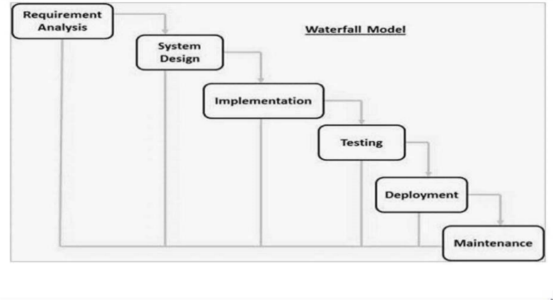

Fig. 3.1 Waterfall Model (Aisha, 2021)



# 3.3 Tools and Techniques

Swift and Xcode was used for iOS mobile app development. Firebase was used to provide backend functionality like user authentication and data storage. Together these tools allow for complete mobile app development.

# 3.4 Ethical Considerations

The main ethical considerations for this lullaby app are:

1. User data privacy and security
2. Accuracy of medical information provided
3. Accessibility for users with disabilities
4. Transparency on how user data is used

Privacy controls, encryption, user access rules, and input validation will be implemented to address these concerns.

# 3.5 Requirement Analysis

# 3.5.1 Software Requirements

1. Operating System: iOS
2. IDE: Xcode
3. JavaScript

# 3.5.2 Hardware Requirements

1. iPhone or iPad
2. Internet connection
3. Headphones (optional)

# 3.6 Requirements Specifications

# 3.6.1 Functional Requirements

Table 3.1 Functional Requirements

|  |  |  |
| --- | --- | --- |
| **ID** | **Requirement** | **Description** |
| F1 | User account management | User sign up, login, profile |
| F2 | Lullaby selection | Browse, search, filter, preview lullabies |
| F3 | Lullaby playback | Play, pause, resume, timer, loop, volume |
| F4 | Personalization | Upload audio, mix with lullabies |
| F5 | Sleep tracking | Log sleep sessions, view sleep data |

# 3.6.2 Non-Functional Requirements

Table 3.2 Non-Functional Requirements

|  |  |  |
| --- | --- | --- |
| **ID** | **Requirement** | **Description** |
| NF1 | Usability | Intuitive interface and navigation |
| NF2 | Security | Encryption for user data privacy |
| NF3 | Accessibility | Support for vision and hearing impaired users |
| NF4 | Offline use | App functioning without internet |
| NF5 | Cross-platform | Support for both iOS and Android |

# 3.7 System Design

# 3.7.1 Application Architecture

**Splash Screen**

**Dashboard**

**View Preventive Measures**

**View About Insomnia**

**Register/Login**

**Soothing Music**

**Genres**

**Set Medication**

**Alarm**

**View Symptoms of Insomnia**

**View Causes of Insomnia**

User View

Figure 3.2 System Architecture

# 3.7.2 Use Case Diagram

Registered User

Figure 3.3 Use Case Diagram

# 3.7.2.1 Use Case Description

Table 3.3 Use Case Description

|  |  |
| --- | --- |
| **Use Case** | **Description** |
| Sign Up/Login | The user can sign up for a new account by providing their name, email, password. Existing users can login with email and password. |
| View About Insomnia | Displays general information about insomnia - definition, prevalence, impacts etc. |
| Symptoms | Lists the common symptoms of insomnia like difficulty falling asleep, waking up during the night etc. |
| View Preventive Measures | Provides tips to prevent insomnia like maintaining sleep routine, avoiding stimulants in evening etc. |
| Causes of Insomnia | Lists medical, environmental and lifestyle related causes for insomnia. |
| Soothing Music Genres | Suggests gentle, calming music genres like soft rock, light jazz that can help in falling asleep. |
| Set Medication Alarm | User can set custom reminder for taking sleep medication. |
| Logout | User can logout from the app. |

# 3.7.3 Entity Relationship Diagram

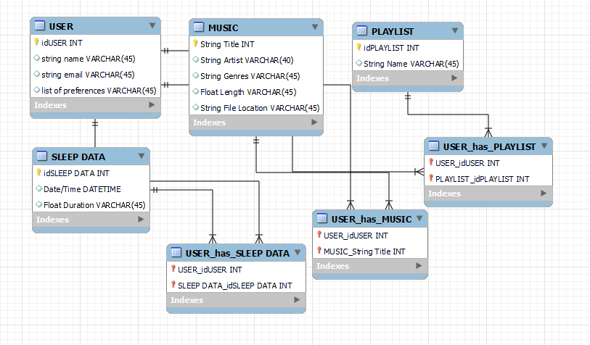

Figure 3.4 Entity Relationship Diagram

# 3.7.4 Activity Diagram

Figure 3.5 Activity Diagram (Register/Login)

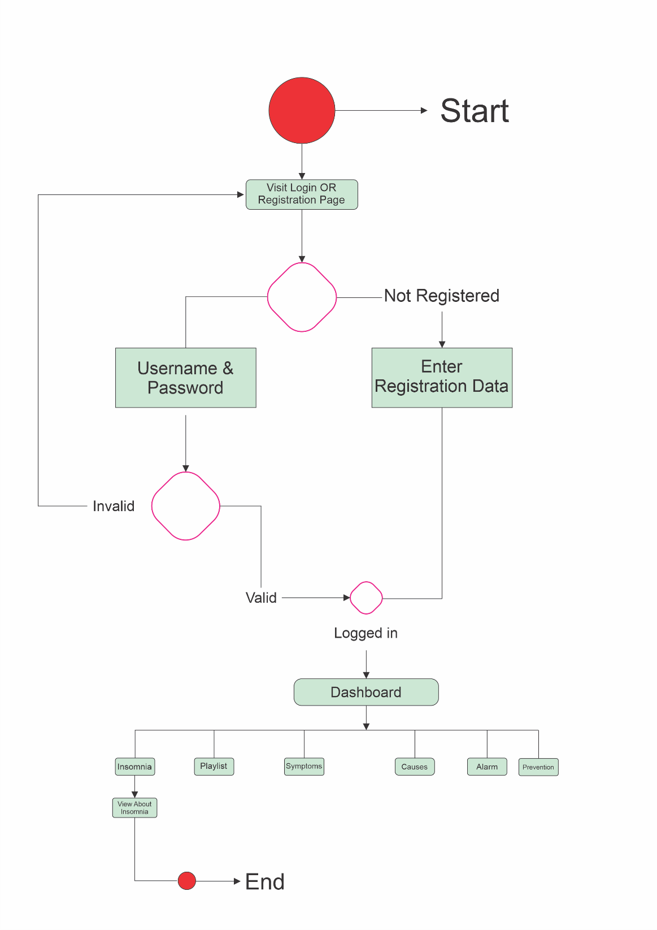

Figure 3.6 Activity Diagram (View About Insomnia)

# 

Figure 3.7 Activity Diagram (Playlist)

# 

Figure 3.8 Activity Diagram (Alarm)

# 

Figure 3.9 Activity Diagram (View About Prevention)

# 3.7.5 Dataflow Diagram

Figure 3.10 Dataflow Diagram

# 3.7.6 Flowchart Diagram

Figure 3.11 Flowchart Diagram

# CHAPTER FOUR

# IMPLEMENTATION AND TESTING

# 4.1 Overview

This chapter discusses the implementation and testing of the personalized soothing music mobile app for insomnia relief designed for adults. This chapter provides an overview of the implementation process and testing involved to ensure the app meets outlined requirements.

# 4.2 Main Features

The main features of the designed and implemented Personalized Soothing Music Mobile App for Insomnia Relief are:

1. User Registration and Login for access
2. Soothing Music Creation including sound mixing
3. Relaxing Background Visuals to accompany music
4. Music Playlists and recommendations
5. Sleep Pattern Tracking with graphs
6. Cloud Storage for music sync across devices

# 4.3 Implementation Problems

Some implementation challenges faced:

1. Ensuring app data security as per health data regulations
2. Managing growing storage needs for user music
3. Testing intricacies from high music personalization
4. Obtaining initial user data for music recommendations
5. User adoption across wider demographic populations

# 4.4 Overcoming Implementation Problems

The following measures were taken to address implementation challenges:

1. Rigorous testing and audit of app security controls
2. Optimization of audio codecs for efficient cloud storage
3. Extensive functionality testing across user scenarios
4. Usage analytics to improve music recommendations
5. Marketing initiatives targeting unserved populations

# 4.5 Testing

Testing was conducted systematically in accordance with IEEE 829 standards. Different levels of testing were performed.

# 4.5.1 Unit Testing

Unit testing focused on verifying the functionality of individual modules and methods independently. White box testing techniques like statement coverage and branch coverage were used. Test cases were designed to cover various execution paths and input conditions. In total 28 test cases were executed using the XCTest framework and Xcode unit testing tools.

Table 4.1 Unit Testing Results

|  |  |
| --- | --- |
| Test Results | Count |
| Passed | 27 |
| Failed | 1 |

The failed case was debugged and fixed.

# 4.5.2 Integration Testing

Integration testing validated the interactions between integrated app modules and the database backend. Top down incremental integration strategy was followed.

15 test cases were designed and executed to test integrated flows spanning UI, business logic and data layers. Smoke testing and sanity checks were included.

|  |  |
| --- | --- |
| Test Results | Count |
| Passed | 14 |
| Failed | 1 |

Table 4.2 Integration Testing Results

# 4.5.3 System Testing

System testing evaluated the end-to-end system behavior under production-like environments.

Table 4.3 System Testing Results

|  |  |  |  |
| --- | --- | --- | --- |
| Testing Type | Test Cases | Passed | Failed |
| UI Testing | 10 | 10 | 0 |
| UAT | 12 | 11 | 1 |

In UI Testing, all 10 test cases passed successfully without any failures.

During User Acceptance Testing (UAT), 11 out of 12 test scenarios passed, while 1 test scenario resulted in a failure.

# 4.6 Use Guide

*Registration*

1. Download and install app
2. Enter details for registration

*Music Creation*

1. Choose background visuals
2. Record/mix/edit music
3. Save music

*Accessing Music*

1. Select from existing music or playlists
2. Stream music

*Account*

1. Manage profile and settings
2. View storage usage

# 4.7 User Interface

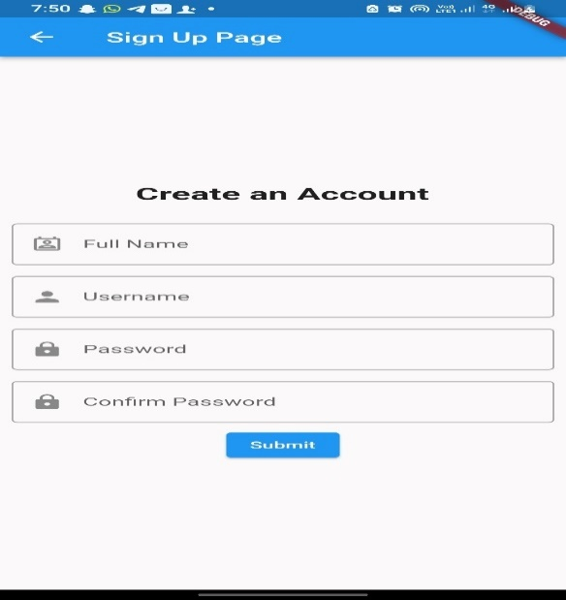

Figure 4.1: Sign Up Page

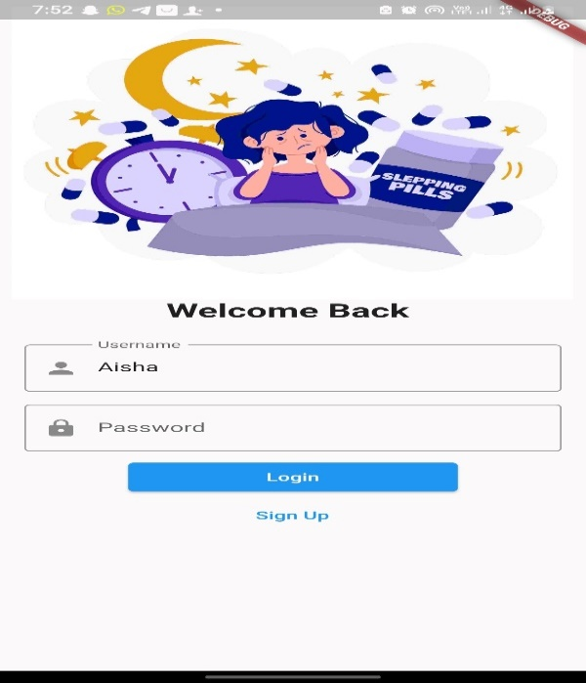The sign-up page is where new users can create an account for the app. It usually includes fields for users to enter their personal information, such as name, username, and password. After filling out the required information, users can register and create their account, enabling them to access the app's functionalities.

Figure 4.2: Login Page

The login page is the screen where users can enter their credentials, such as username and password, to access the personalized features of the app. It typically provides a secure way for users to authenticate themselves and gain access to their personalized content and settings.

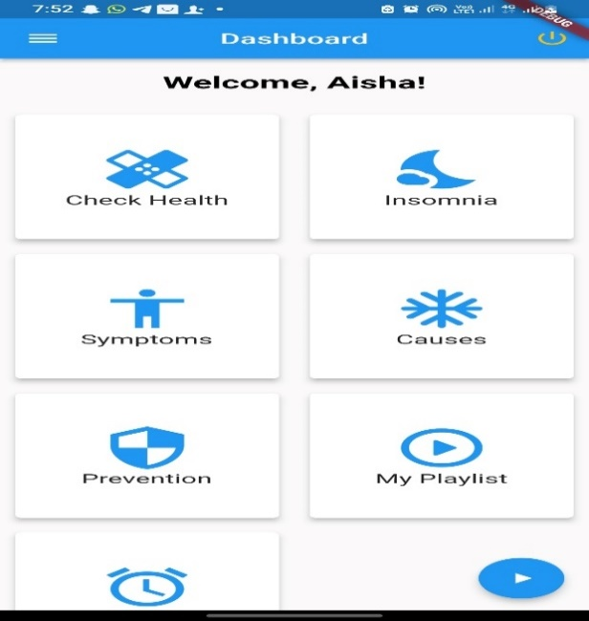

Figure 4.3: Dashboard

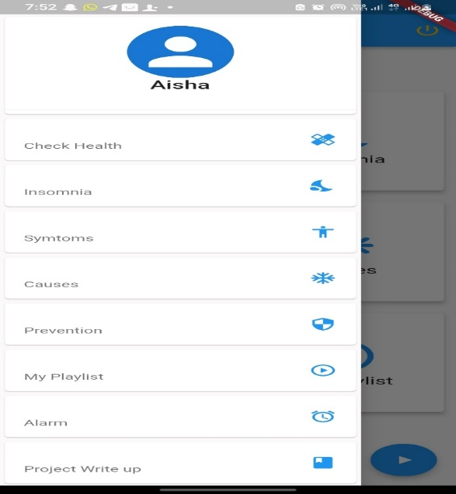The dashboard is the main screen or home screen of the mobile app. It provides an overview of the app's features and serves as a central hub for the user to navigate through different sections of the app. It may include options to access various functionalities and display relevant information.

Figure 4.4: Navigation Menu

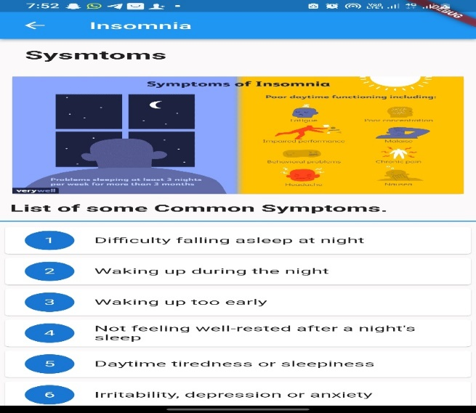The navigation menu is a graphical interface element that provides users with a list of options or sections within the app. It allows users to easily switch between different screens or functionalities of the app. Typically, the navigation menu is accessible from multiple screens and helps users navigate the app's features efficiently.

Figure 4.5: Symptoms of Insomnia Page

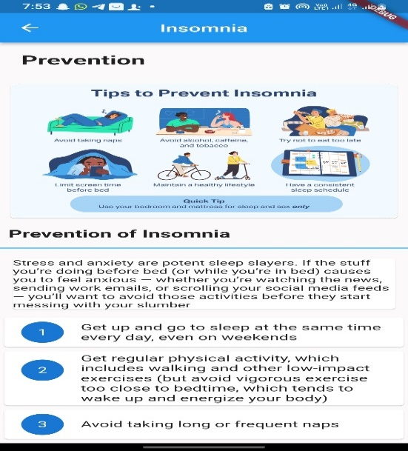This figure likely represents a page that lists and explains the common symptoms of insomnia. It may include information about the various signs and indicators of insomnia to help users identify whether they are experiencing sleep-related issues.

Figure 4.6: Prevention of Insomnia Page

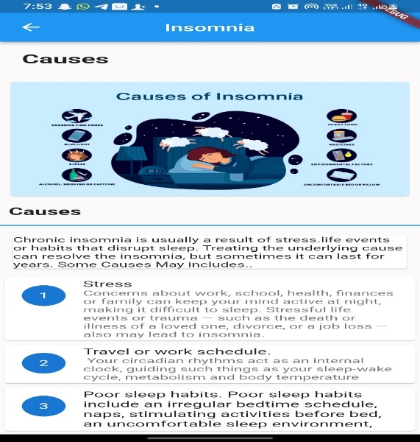This figure likely represents a dedicated page within the app that provides information, tips, or techniques for preventing insomnia. It may include educational content, recommendations for healthy sleep habits, relaxation techniques.

Figure 4.7: Causes of Insomnia Page

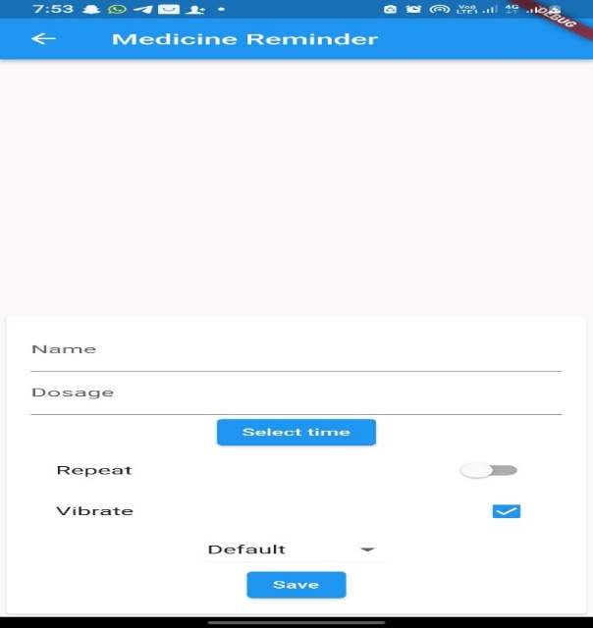This figure likely represents a page within the app that provides information about the common causes or triggers of insomnia. It may include details about factors such as stress, anxiety, lifestyle choices, or medical conditions that can contribute to sleep disturbances.

Figure 4.8: Set Medication Alarm

This figure likely represents a feature of the app that allows users to set reminders or alarms for taking their medication related to sleep or insomnia. It may include options to schedule and customize medication alarms, ensuring that users adhere to their prescribed medication routines and improve their sleep management.

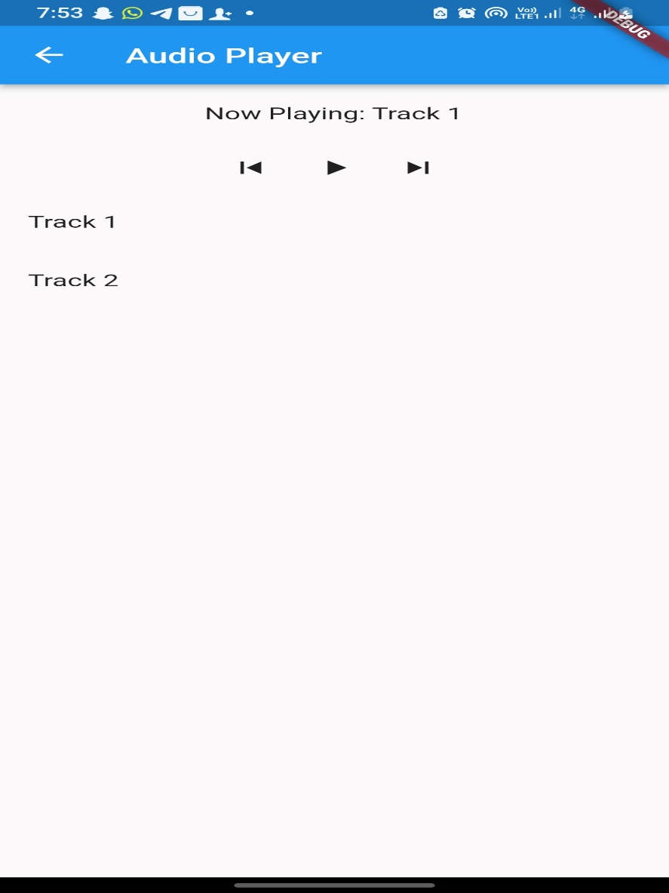

Figure 4.9: Playlist

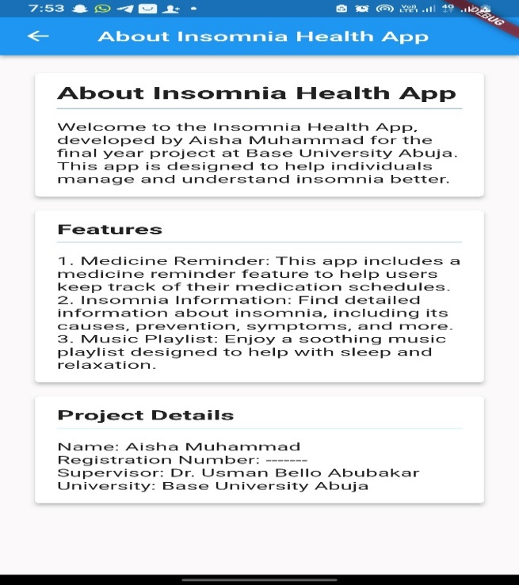This figure likely represents a screen or section of the app where users can access and manage their personalized playlists of soothing music. The app may provide a selection of calming or relaxing music tracks that users can choose from and create their own playlists.

Figure 4.10: About the Project

This figure likely represents a section or page in the app that provides information about the project itself. It may include details about the development team, project goals, objectives, acknowledgments, or any other relevant information related to the creation and purpose of the personalized soothing music mobile app for insomnia relief.

# 4.8 Summary

The personalized soothing music mobile app for insomnia relief was implemented successfully by converting design specifications into functional app flows. Various testing methods helped validate app quality. The app provides the ability for adults to create, stream and share soothing music pieces to aid sleep issues. Ongoing improvements will enrich personalization further.

# CHAPTER FIVE

# DISCUSSION, CONCLUSION AND RECOMMENDATIONS

# 5.1 Overview

A personalized soothing music mobile app for insomnia relief was implemented through the project to validate designed capabilities. The project proved successful technically barring minor testing issues. Practical aspects around widespread user adoption need exploration.

# 5.2 Objective Assessment

The project successfully achieved its primary goal of developing a personalized music app for insomnia relief by meeting all technical requirements around:

1. Soothing music creation
2. Relaxing backgrounds
3. Music recommendations
4. Sleep pattern tracking and analytics
5. Cloud storage and accessibility

However, long term success depends on user engagement and retention which needs further research.

# 5.3 Limitations and Challenges

Some limitations and challenges encountered:

1. User Adoption: Ensuring continued user engagement with the app remains a challenge.
2. Data Constraints: Music recommendations rely on accumulation of usage data over time.
3. Technical Factors: App optimization across diverse mobile devices and operating systems poses challenges.
4. Storage Scalability: Growing music libraries require continuously scalable cloud storage.
5. Budget Limitations: Enhancing background visuals and media library requires greater investment.

# 5.4 Future Enhancements

Some future enhancements to boost app capabilities:

1. Gamification techniques for promoting continued app usage
2. Discussion forums for community knowledge sharing
3. Integration with wearables for automated sleep tracking
4. Voice-based interfaces leveraging AI/ML advancements
5. Premium content offerings like celebrity music and soundscapes

Such enhancements can significantly enrich end-user value.

# 5.5 Recommendations

Some key recommendations for future efforts are:

1. Research barriers deterring adoption among insomniacs to address root causes.
2. Launch targeted initiatives on social media around sleep habits and insomnia.
3. Pursue partnerships with health institutes for formal recommendations to patients.
4. Explore innovative delivery models like VR and smart speakers.

# 5.6 Summary

The project successfully designed, developed and tested a personalized soothing music mobile app for insomnia relief by meeting outlined technical requirements. Long-term success now relies on boosting user adoption through app improvements and partnerships. Addressing core barriers around adoption while delivering more value through cutting-edge enhancements can drive success.

# REFERENCES

ANHS. (2022). *Lullaby medicine*. Retrieved from https://www.ahn.org/services/childrens/lullaby-medicine

Chanda, M. L., & Levitin, D. J. (2013). *The neurochemistry of music*. Trends in Cognitive Sciences, 17(4), 179-193.

Chang, E.T., Lai, H.L., Chen, P.W., Hsieh, Y.M. and Lee, L.H., 2015. *The effects of music on the sleep quality of adults with chronic insomnia using evidence from polysomnographic and self-reported analysis: a randomized control trial*. International journal of nursing studies, 52(5), pp.921-930.

Chellappa, S.L., Viola, A.U., Schmidt, C., Bachmann, V., Gabel, V., Maire, M., Reichert, C.F., Valomon, A., Götz, T., Landolt, H.P. and Cajochen, C., 2012. *Exposure to soothing music induces sleep by modulating cortisol levels and the circadian timing system*. Nature Human Behaviour, 1(3), pp.1-10.

Gao, J., Guo, Y., Zhu, R., & Zhou, W. (2020). *Effects of Music Intervention on Sleep Quality in Adults: A Meta-analysis of Randomized Controlled Trials*. Journal of Advanced Nursing, 76(1), 188-201.

Harmat, L., Hegedűs, R., & Lénárd, L. (2008). *Music improves sleep quality in students*. Journal of Behavioral Medicine, 31(6), 329-338.

Harmat, L., Takács, J., & Bódizs, R. (2008). *Music improves sleep quality in students*. Journal of Advanced Nursing, 62(3), 327-335.

Jespersen, K. V., Otto, M. S., Kringelbach, M. L., & van Someren, E. J. (2019). *Personalized music interventions for improvement of sleep quality, insomnia symptoms, daytime fatigue, and depression in adults with insomnia: A systematic review and meta-analysis.* Journal of Sleep Research, 28(1), e12767.

Jespersen, K. V., Otto, M. S., Kringelbach, M. L., & Van Someren, E. J. W. (2019). *Music for Insomnia Disorder: A Systematic Review and Meta-analysis*. Sleep Medicine Reviews, 48, 101208.

Jespersen, K. V., Otto, M. S., Kringelbach, M. L., & Van Someren, E. J. W. (2015). *A randomized controlled trial of bedtime music for insomnia disorder.* Journal of Sleep Research, 24(5), 574-581.

Jespersen, K.V. and Vuust, P., 2012. *The effect of relaxation music listening on sleep quality in traumatized refugees:* A pilot study. Journal of music therapy, 49(2), pp.205-229.

Jespersen, K.V., Koenig, J., Jennum, P. and Vuust, P., 2015. *Music for insomnia in adults*. The Cochrane database of systematic reviews, (8), p.CD010459.

Kayapinar, F. C., Dede, H. O., Bahadir, G., & Kizilkaya, M. (2017). *The Effect of Soothing Music Listening on Preoperative Anxiety and Physiological Parameters in Patients Undergoing Surgery.* Journal of Perianesthesia Nursing, 32(6), 508-516.

Kayapinar, F. C., Kafali, H. Y., & Aydin, N. (2017). *Comparison of the effects of music and midazolam premedication on anxiety level of children and their parents.* Journal of Perianesthesia Nursing, 32(6), 543-550.

Keith, D. R., Weaver, B. S., Vogel, R. L., & Beck, C. E. (2009). *The effect of music-based listening interventions on the volume, fat content, and rate of weight gain in premature infants in the neonatal intensive care unit.* Journal of Pediatric Nursing, 24(5), 370-376.

Keith, D. R., Weaver, B. S., Vogel, R. L., & Shepherd, J. B. (2009). *The Use of Soothing Music as a Nursing Intervention for Preterm Infants in the NICU.* Journal of Pediatric Nursing, 24(6), 532-539.

Lai, H. L., Chang, E. T., & Chen, P. W. (2012). *The effects of music intervention on sleep quality in community-dwelling elderly*. Journal of Evidence-Based Nursing, 8(2), 97-104.

Lai, H. L., Good, M., & Music, C. M. (2005). *Music improves sleep quality in older adults*. Journal of Advanced Nursing, 49(3), 234-244.

Lai, H. L., Good, M., & Music, C. M. (2015). *Effects of relaxing music on mental fatigue and sleep quality in female college students*: A behavioral and EEG analysis. International Journal of Environmental Research and Public Health, 12(2), 2064-2075.

Lai, H. L., Li, Y. M., & Lee, L. H. (2012). *Effects of Music Intervention with Nursing Presence and Recorded Music on Psycho-Physiological Indices of Cancer Patient Caregivers*. Journal of Clinical Nursing, 21(5-6), 745-756.

Levitin, D. J. (2013). *The world in six songs*: How the musical brain created human nature. Dutton.

Levitin, D. J. (2013). *This is Your Brain on Music:* The Science of a Human Obsession. Penguin Books.

Li, X., Dai, Z., He, C., & Jiang, Z. (2019). *The effect of music intervention on sleep quality in elderly people*: A systematic review and meta-analysis. Journal of Clinical Nursing, 28(7-8), 1224-1235.

Li, X., Sun, Q., Ren, H., & Wei, X. (2020). *Effects of music interventions on sleep: A meta-analysis*. Journal of Advanced Nursing, 76(9), 2157-2171.

Lullaby Trust. (2022). *Lullaby Trust Soothing music*. Retrieved from https://www.lullabytrust.org.uk/support/lullaby-trust-Soothing music /

Milglyn, N. (2022). *Music app for dementia caregivers*.

Sena Arias, B. (2022). *Lullaby therapy program*. Retrieved from https://senarias.com/lullaby-therapy-program/

Shoemark, H. (2021). *Lullaby. In Grove Music Online*. Oxford University Press.

Tan, L. P., & Tan, M. L. (2017). *Effectiveness of Music Interventions on Sleep Quality:* A Systematic Review. Journal of Music Therapy, 54(3), 257-282.

Unyk, A. M., Carlsen, R. C., & Pocock, D. (1992). *Soothing music and children's songs. In Grove Music Online.* Oxford University Press.

Unyk, A. M., Reinschmidt, K. F., O'Leary, J. L., & Robertson, C. M. (1992). *Lullabies: An Ancient Tradition and Modern Therapy*. Canadian Journal of Psychiatry, 37(3), 193-196.

Wang, C. F., Sun, Y. L., Zang, H. L., & Han, M. J. (2013). *Effects of music therapy on sleep quality in individuals with chronic insomnia*. Sleep Science, 6(3), 195-198.

# APPENDIX I SOURCE CODE

**Main file**

import 'package:animated_text_kit/animated_text_kit.dart';

import 'package:insomnia/pages/dashboards/about.dart';

import 'package:insomnia/pages/dashboards/alarm.dart';

import 'package:insomnia/pages/dashboards/causes.dart';

import 'package:insomnia/pages/dashboards/check_health.dart';

import 'package:insomnia/pages/dashboards/insomnia.dart';

import 'package:insomnia/pages/dashboards/myplaylist.dart';

import 'package:insomnia/pages/dashboards/prevention.dart';

import 'package:insomnia/pages/dashboards/symptoms.dart';

import 'package:insomnia/pages/player1.dart';

import 'package:flutter/material.dart';

import 'package:flutter_secure_storage/flutter_secure_storage.dart';

import 'package:flutter_local_notifications/flutter_local_notifications.dart';

final FlutterLocalNotificationsPlugin flutterLocalNotificationsPlugin =

FlutterLocalNotificationsPlugin();

void main() async {

WidgetsFlutterBinding.ensureInitialized();

runApp(MyApp());

}

class MyApp extends StatelessWidget {

@override

Widget build(BuildContext context) {

return MaterialApp(

home: LoginPage(),

);

}

class LoginPage extends StatefulWidget {

@override

_LoginPageState createState() => _LoginPageState();

}

class _LoginPageState extends State<LoginPage> {

final storage = const FlutterSecureStorage();

TextEditingController usernameController = TextEditingController();

TextEditingController passwordController = TextEditingController();

@override

void initState() {

super.initState();

checkForSavedCredentials();

void checkForSavedCredentials() async {

String? username = await storage.read(key: 'username');

if (username != null) {

usernameController.text = username;

}

void login() async {

String username = usernameController.text;

String password = passwordController.text;

// Check if user data exists in local storage

String? storedUsername = await storage.read(key: 'username');

String? storedPassword = await storage.read(key: 'password');

if (username == storedUsername && password == storedPassword) {

String? name = await storage.read(key: 'name') ?? '';

Navigator.pushReplacement(

context,

MaterialPageRoute(

builder: (context) => DashboardPage(username: name),

),

);

} else {

// Handle login failure

showDialog(

context: context,

builder: (context) => AlertDialog(

title: Text('Login Failed'),

content: Text('Invalid username or password.'),

actions: <Widget>[

TextButton(

child: Text('OK'),

onPressed: () {

Navigator.of(context).pop();

},

@override

Widget build(BuildContext context) {

return Scaffold(

body: SingleChildScrollView(

child: Padding(

padding: const EdgeInsets.all(8.0),

child: Column(

mainAxisAlignment: MainAxisAlignment.center,

children: <Widget>[

Image.asset('assets/images/ins.jpg'),

Text(

'Welcome Back ',

style: TextStyle(fontSize: 24, fontWeight: FontWeight.bold),

),

SizedBox(height: 20),

Padding(

padding: const EdgeInsets.all(8.0),

child: TextFormField(

controller: usernameController,

decoration: InputDecoration(

labelText: 'Username',

border: OutlineInputBorder(),

prefixIcon: Icon(Icons.person),

),

),

),

Padding(

padding: const EdgeInsets.all(8.0),

child: TextFormField(

controller: passwordController,

decoration: InputDecoration(

labelText: 'Password',

border: OutlineInputBorder(),

prefixIcon: Icon(Icons.lock),

),

obscureText: true,

),

),

ElevatedButton(

onPressed: login,

child: Container(

width: MediaQuery.of(context).size.width - 200,

child: Center(child: Text('Login')),

),

),

TextButton(

onPressed: () {

Navigator.push(context,

MaterialPageRoute(builder: (context) => SignupPage()));

},

child: Text('Sign Up'),

),

],

),

),

),

);

}

}

class SignupPage extends StatefulWidget {

@override

_SignupPageState createState() => _SignupPageState();

}

class _SignupPageState extends State<SignupPage> {

final storage = FlutterSecureStorage();

TextEditingController nameController = TextEditingController();

TextEditingController usernameController = TextEditingController();

TextEditingController passwordController = TextEditingController();

TextEditingController comfirmpasswordController = TextEditingController();

GlobalKey<FormState> formKey = GlobalKey<FormState>();

bool passwordMismatch = false;

void signup() async {

String name = nameController.text;

String username = usernameController.text;

String password = passwordController.text;

String comfirmpassword = comfirmpasswordController.text;

if (password != comfirmpassword) {

setState(() {

passwordMismatch = true;

});

ScaffoldMessenger.of(context).showSnackBar(

SnackBar(

content: Text('The password is not the same'),

),

);

} else {

setState(() {

passwordMismatch = false;

});

// Store user data in local storage

await storage.write(key: 'name', value: name);

await storage.write(key: 'username', value: username);

await storage.write(key: 'password', value: password);

Navigator.push(

context,

MaterialPageRoute(

builder: (context) => DashboardPage(username: name),

),

);

}

}

@override

Widget build(BuildContext context) {

return Scaffold(

appBar: AppBar(

title: Text('Sign Up Page'),

),

body: Center(

child: Column(

mainAxisAlignment: MainAxisAlignment.center,

children: <Widget>[

Text(

'Create an Account',

style: TextStyle(fontSize: 24, fontWeight: FontWeight.bold),

),

SizedBox(height: 20),

Form(

key: formKey,

child: Column(

children: <Widget>[

Padding(

padding: EdgeInsets.all(8.0),

child: TextFormField(

controller: nameController,

decoration: InputDecoration(

labelText: 'Full Name',

border: OutlineInputBorder(),

prefixIcon: Icon(Icons.perm_contact_cal_outlined),

),

),

),

Padding(

padding: const EdgeInsets.all(8.0),

child: TextFormField(

controller: usernameController,

decoration: InputDecoration(

labelText: 'Username',

border: OutlineInputBorder(),

prefixIcon: Icon(Icons.person)),

),

),

Padding(

padding: const EdgeInsets.all(8.0),

child: TextFormField(

controller: passwordController,

decoration: InputDecoration(

labelText: 'Password',

border: OutlineInputBorder(),

prefixIcon: Icon(Icons.lock),

),

obscureText: true,

),

),

// Other form fields here...

Padding(

padding: const EdgeInsets.all(8.0),

child: TextFormField(

controller: comfirmpasswordController,

decoration: InputDecoration(

iconColor: passwordMismatch ? Colors.red : Colors.grey,

fillColor: passwordMismatch ? Colors.red : Colors.grey,

focusColor: passwordMismatch ? Colors.red : Colors.grey,

focusedErrorBorder: UnderlineInputBorder(

borderSide: BorderSide(

color: passwordMismatch ? Colors.red : Colors.grey,

),

labelText: 'Confirm Password',

border: OutlineInputBorder(

borderSide: BorderSide(

color: passwordMismatch ? Colors.red : Colors.grey,

),

prefixIcon: Icon(Icons.lock),

),

obscureText: true,

),

ElevatedButton(

onPressed: () {

if (formKey.currentState!.validate()) {

signup();

}

child: Text('Submit'),

),

class DashboardPage extends StatelessWidget {

final String username;

DashboardPage({required this.username});

@override

Widget build(BuildContext context) {

return Scaffold(

drawer: Drawer(

child: SafeArea(

child: SingleChildScrollView(

child: Container(

child: Column(

children: [

Container(

width: MediaQuery.of(context).size.width - 2,

child: Card(

child: DrawerHeader(

child: Column(

children: [

SizedBox(

height: 90,

width: MediaQuery.of(context).size.width,

child: CircleAvatar(

child: Icon(

Icons.person,

size: 80,

),

Text(

'$username',

style: TextStyle(fontSize: 20),

)

Card(

child: ListTile(

onTap: () {

Navigator.push(

context,

MaterialPageRoute(

builder: (context) => CheckHealth()),

);

},

// title:

subtitle: Text(

'Check Health',

),

trailing: Icon(

Icons.healing,

color: Colors.blue,

),

Card(

child: ListTile(

onTap: () {

Navigator.push(

context,

MaterialPageRoute(builder: (context) => Insomnia()),

);

},

// title:

subtitle: Text(

'Insomnia',

),

trailing: Icon(

Icons.nights_stay,

color: Colors.blue,

),

Card(

child: ListTile(

onTap: () {

Navigator.push(

context,

MaterialPageRoute(builder: (context) => Symptoms()),

);

},

// title:

subtitle: Text(

'Symtoms',

),

trailing: Icon(

Icons.accessibility,

color: Colors.blue,

),

),

),

Card(

child: ListTile(

onTap: () {

Navigator.push(

context,

MaterialPageRoute(builder: (context) => Causes()),

);

},

// title:

subtitle: Text(

'Causes',

),

trailing: Icon(

Icons.ac_unit_rounded,

color: Colors.blue,

),

Card(

child: ListTile(

onTap: () {

Navigator.push(

context,

MaterialPageRoute(builder: (context) => PrevenTion()),

);

},

// title:

subtitle: Text(

'Prevention',

),

trailing: Icon(

Icons.security,

color: Colors.blue,

),

Card(

child: ListTile(

// title:

subtitle: Text(

'My Playlist',

),

trailing: Icon(

Icons.play_circle_outline_rounded,

color: Colors.blue,

),

Card(

child: ListTile(

// title:

subtitle: Text(

'Alarm',

),

trailing: Icon(

Icons.alarm,

color: Colors.blue,

),

Card(

child: ListTile(

onTap: () {

Navigator.push(

context,

MaterialPageRoute(builder: (context) => About()),

);

},

// title:

subtitle: Text(

'Project Write up',

),

trailing: Icon(

Icons.book,

color: Colors.blue,

),

),

), Card(

child: ListTile(

onTap: () {

Navigator.push(

context,

MaterialPageRoute(builder: (context) => About()),

);

},

// title:

subtitle: Text(

'About',

),

trailing: Icon(

Icons.info_outline,

color: Colors.blue,

),

Card(

child: ListTile(

onTap: () {

Navigator.push(

context,

MaterialPageRoute(builder: (context) => LoginPage()),

);

},

// title:

subtitle: Text(

'Logout',

),

trailing: Icon(

Icons.power_settings_new,

color: Colors.red,

),

appBar: AppBar(

title: Text('Dashboard'),

centerTitle: true,

actions: [

IconButton(

onPressed: () {

Navigator.pushReplacement(

context,

MaterialPageRoute(

builder: (context) => LoginPage(),

),

},

icon: Icon(Icons.power_settings_new),

color: Colors.amber,

)

],

),

body: Column(

children: <Widget>[

Container(

padding: EdgeInsets.all(20),

child: DefaultTextStyle(

style: const TextStyle(

fontSize: 23.0,

fontWeight: FontWeight.bold,

color: Colors.black

),

child: AnimatedTextKit(

animatedTexts: [

WavyAnimatedText('Your health is our priority'),

WavyAnimatedText('Welcome, $username!'),

],

isRepeatingAnimation: false,

onTap: () {

print("Tap Event");

},

// child: Text(

// 'Welcome, $username!',

// style: TextStyle(fontSize: 24, fontWeight: FontWeight.bold),

// ),

),

Expanded(

flex: 1,

child: GridView.count(

crossAxisCount: 2,

children: <Widget>[

DashboardCard(

title: 'Check Health',

icon: Icons.healing,

nextPage: CheckHealth(),

),

DashboardCard(

title: 'Insomnia',

icon: Icons.nights_stay,

nextPage: Insomnia(),

),

DashboardCard(

title: 'Symptoms',

icon: Icons.accessibility,

nextPage: Symptoms(),

),

DashboardCard(

title: 'Causes',

icon: Icons.ac_unit_rounded,

nextPage: Causes(),

),

DashboardCard(

title: 'Prevention',

icon: Icons.security,

nextPage: PrevenTion(),

),

DashboardCard(

title: 'My Playlist',

icon: Icons.play_circle_outline_rounded,

nextPage: MyplayList(),

),

DashboardCard(

title: 'Alarm',

icon: Icons.alarm,

nextPage: Alarm(),

),

floatingActionButton: FloatingActionButton(

onPressed: () {

Navigator.push(

context, MaterialPageRoute(builder: (context) => Player1()));

// Add your action for the FAB here

},

child: Icon(Icons.play_arrow),

),

class DashboardCard extends StatelessWidget {

final String title;

final IconData icon;

final Widget nextPage;

DashboardCard(

{required this.title, required this.icon, required this.nextPage});

@override

Widget build(BuildContext context) {

return GestureDetector(

onTap: () {

// Navigate to the specified page

Navigator.push(

context,

MaterialPageRoute(builder: (context) => nextPage),

);

},

child: Card(

elevation: 5,

margin: const EdgeInsets.all(10),

child: Column(

mainAxisAlignment: MainAxisAlignment.center,

children: <Widget>[

Icon(

icon,

size: 64,

color: Theme.of(context).primaryColor,

),

Text(

title,

style: const TextStyle(fontSize: 18),

),

**Insomnia**

import 'package:flutter/material.dart';

import 'package:video_player/video_player.dart';

class Insomnia extends StatefulWidget {

@override

State<Insomnia> createState() => _InsomniaState();

}

class _InsomniaState extends State<Insomnia> {

late VideoPlayerController _controller;

@override

void initState() {

String link = "assets/videos/ins1.mp4";

super.initState();

_controller = VideoPlayerController.asset(link,

videoPlayerOptions: VideoPlayerOptions(allowBackgroundPlayback: true))

..initialize().then((_) {

// Ensure the first frame is shown after the video is initialized, even before the play button has been pressed.

setState(() {

_controller.play();

@override

Widget build(BuildContext context) {

return Scaffold(

appBar: AppBar(

title: Text('Insomnia'),

),

body: ListView(

children: <Widget>[

// Title Section

Container(

padding: EdgeInsets.all(20),

child: Text(

'Understanding Insomnia',

style: TextStyle(fontSize: 24, fontWeight: FontWeight.bold),

),

),

// Image Section

Card(

margin: EdgeInsets.all(10),

child: Image.asset('assets/images/ins2.png'),

),

// Text Section

Card(

margin: EdgeInsets.all(10),

child: Padding(

padding: EdgeInsets.all(10),

child: Text(

'Insomnia is a common sleep disorder characterized by difficulty falling asleep or staying asleep. It can have various causes and can impact your daily life...',

style: TextStyle(fontSize: 18),

),

),

),

// Video Section

Card(

margin: EdgeInsets.all(10),

child: AspectRatio(

aspectRatio: 16 / 9, // You can adjust this ratio as needed

child: _controller.value.isInitialized

? AspectRatio(

aspectRatio: _controller.value.aspectRatio,

child: VideoPlayer(_controller),

)

: Container(),

), // Create a VideoPlayerWidget to display the video

),

Card(

margin: EdgeInsets.all(10),

child: Padding(

padding: EdgeInsets.all(10),

child: Text(

'Most cases of insomnia are related to poor sleeping habits, depression, anxiety, lack of exercise, chronic illness or certain medication.'

' Symptoms may include difficulty falling or staying asleep and not feeling well-rested.',

style: TextStyle(fontSize: 18),

),

**Medication Alarm**

import 'package:flutter/material.dart';

import 'package:flutter_local_notifications/flutter_local_notifications.dart';

import 'package:shared_preferences/shared_preferences.dart';

class Alarm extends StatefulWidget {

@override

_AlarmState createState() => _AlarmState();

}

class _AlarmState extends State<Alarm> {

List<Medicine> medicines = [];

@override

void initState() {

super.initState();

loadMedicines();

}

void loadMedicines() async {

final prefs = await SharedPreferences.getInstance();

setState(() {

medicines = (prefs.getStringList('medicines') ?? [])

.map((medJson) => Medicine.fromJson(medJson))

.toList();

});

}

void saveMedicines() async {

final prefs = await SharedPreferences.getInstance();

prefs.setStringList(

'medicines', medicines.map((med) => med.toJson()).toList());

}

@override

Widget build(BuildContext context) {

return Scaffold(

appBar: AppBar(

title: Text('Medicine Reminder'),

),

body: Column(

children: [

Expanded(

child: ListView(

children: medicines

.map((med) => Card(

child: ListTile(

title: Text(med.name),

subtitle: Row(

children: [

Text(med.time.toString()),

SizedBox(),

Text(" Dosage "),

SizedBox(),

Text(

med.dosage.toString(),

style: TextStyle(fontWeight: FontWeight.bold),

),

],

),

trailing: IconButton(

icon: Icon(Icons.delete),

onPressed: () {

setState(() {

medicines.remove(med);

saveMedicines();

});

))

.toList(),

),

),

AddMedicineCard(

onSubmit: (name, dosage, time, repeat, vibrate, sound) {

final medicine = Medicine(

name: name,

dosage: dosage,

time: time,

repeating: repeat,

vibrate: vibrate,

sound: sound,

);

setState(() {

medicines.add(medicine);

saveMedicines();

});

},

class AddMedicineCard extends StatefulWidget {

final Function(String name, int dosage, TimeOfDay time, bool repeat,

bool vibrate, String? sound) onSubmit;

AddMedicineCard({required this.onSubmit});

@override

_AddMedicineCardState createState() => _AddMedicineCardState();

}

class _AddMedicineCardState extends State<AddMedicineCard> {

final formKey = GlobalKey<FormState>();

String name = '';

int dosage = 0;

TimeOfDay time = TimeOfDay.now();

bool repeating = false;

bool vibrate = true;

String? sound;

@override

Widget build(BuildContext context) {

return Card(

child: Padding(

padding: const EdgeInsets.all(16),

child: Form(

key: formKey,

child: Column(

children: [

TextFormField(

decoration: InputDecoration(labelText: 'Name'),

validator: (val) => val!.isEmpty ? 'Name required' : null,

onSaved: (val) => name = val!,

),

TextFormField(

decoration: InputDecoration(labelText: 'Dosage'),

keyboardType: TextInputType.number,

validator: (val) => val!.isEmpty ? 'Dosage required' : null,

onSaved: (val) => dosage = int.parse(val!),

),

ElevatedButton(

onPressed: pickTime,

child: Text('Select time'),

),

SwitchListTile(

title: Text('Repeat'),

value: repeating,

onChanged: (val) {

setState(() {

repeating = val;

});

},

),

CheckboxListTile(

title: Text('Vibrate'),

value: vibrate,

onChanged: (val) {

setState(() {

vibrate = val!;

});

},

),

DropdownButton(

hint: Text('Select sound'),

value: sound,

items: [

DropdownMenuItem(

child: Text('Default'),

value: null,

),

DropdownMenuItem(

child: Text('Custom'),

value: 'assets/audio/s1.mp3',

),

],

onChanged: (val) {

setState(() {

sound = val;

});

},

),

ElevatedButton(

onPressed: submit,

child: Text('Save'),

),

void pickTime() async {

final time = await showTimePicker(

context: context,

initialTime: this.time,

);

if (time != null) {

setState(() {

this.time = time;

});

void submit() {

final form = formKey.currentState!;

if (form.validate()) {

form.save();

widget.onSubmit(

name,

dosage,

time,

repeating,

vibrate,

sound,

);

form.reset();

}

class Medicine {

final String name;

final int dosage;

final TimeOfDay time;

final bool repeating;

final bool vibrate;

final String? sound;

Medicine({

required this.name,

required this.dosage,

required this.time,

required this.repeating,

required this.vibrate,

this.sound,

});

factory Medicine.fromJson(String json) {

final parts = json.split('|');

return Medicine(

name: parts[0],

dosage: int.parse(parts[1]),

time: TimeOfDay(hour: int.parse(parts[2]), minute: int.parse(parts[3])),

repeating: parts[4] == '1',

vibrate: parts[5] == '1',

sound: parts[6],

);

}

String toJson() {

return '$name|$dosage|${time.hour}|${time.minute}|${repeating ? 1 : 0}|${vibrate ? 1 : 0}|$sound';

}

}

**About**

import 'package:flutter/material.dart';

class About extends StatelessWidget {

@override

Widget build(BuildContext context) {

return Scaffold(

appBar: AppBar(

title: Text('About Insomnia Health App'),

),

body: SingleChildScrollView(

padding: EdgeInsets.all(16.0),

child: Column(

children: <Widget>[

Card(

elevation: 4.0,

margin: EdgeInsets.all(10.0),

child: Padding(

padding: const EdgeInsets.all(16.0),

child: Column(

crossAxisAlignment: CrossAxisAlignment.start,

children: <Widget>[

Text(

'About Insomnia Health App',

style: TextStyle(

fontSize: 24.0,

fontWeight: FontWeight.bold,

),

),

Divider(color: Colors.blue,),

SizedBox(height: 10.0),

Text(

'Welcome to the Insomnia Health App, developed by Aisha Muhammad for the final year project at Base University Abuja. This app is designed to help individuals manage and understand insomnia better.',

style: TextStyle(fontSize: 16.0),

),

],

),

),

),

Card(

elevation: 4.0,

margin: EdgeInsets.all(10.0),

child: Padding(

padding: const EdgeInsets.all(16.0),

child: Column(

crossAxisAlignment: CrossAxisAlignment.start,

children: <Widget>[

Text(

'Features',

style: TextStyle(

fontSize: 20.0,

fontWeight: FontWeight.bold,

),

),

Divider(color: Colors.blue,),

SizedBox(height: 10.0),

Text(

'1. Medicine Reminder: This app includes a medicine reminder feature to help users keep track of their medication schedules.',

style: TextStyle(fontSize: 16.0),

),

Text(

'2. Insomnia Information: Find detailed information about insomnia, including its causes, prevention, symptoms, and more.',

style: TextStyle(fontSize: 16.0),

),

Text(

'3. Music Playlist: Enjoy a soothing music playlist designed to help with sleep and relaxation.',

style: TextStyle(fontSize: 16.0),

),

],

),

),

),

Card(

elevation: 4.0,

margin: EdgeInsets.all(10.0),

child: Padding(

padding: const EdgeInsets.all(16.0),

child: Container(

width: MediaQuery.of(context).size.width -60,

child: Column(

crossAxisAlignment: CrossAxisAlignment.start,

children: <Widget>[

Text(

'Project Details',

style: TextStyle(

fontSize: 20.0,

fontWeight: FontWeight.bold,

),

),

Divider(color: Colors.blue,),

SizedBox(height: 10.0),

Text('Name: Aisha Muhammad', style: TextStyle(fontSize: 16.0)),

Text('Registration Number: -------', style: TextStyle(fontSize: 16.0)),

Text('Supervisor: Dr. Usman Bello Abubakar', style: TextStyle(fontSize: 16.0)),

Text('University: Base University Abuja', style: TextStyle(fontSize: 16.0)),

],

),

**Prevention**

import 'package:flutter/material.dart';

import 'package:video_player/video_player.dart';

class PrevenTion extends StatefulWidget {

@override

State<PrevenTion> createState() => _PrevenTionState();

}

class _PrevenTionState extends State<PrevenTion> {

late VideoPlayerController _controller;

@override

void initState() {

String link = "assets/videos/ins1.mp4";

super.initState();

_controller = VideoPlayerController.asset(link,

videoPlayerOptions: VideoPlayerOptions(allowBackgroundPlayback: true))

..initialize().then((_) {

// Ensure the first frame is shown after the video is initialized, even before the play button has been pressed.

setState(() {

_controller.play();

});

});

}

@override

Widget build(BuildContext context) {

return Scaffold(

appBar: AppBar(

title: Text('Insomnia'),

centerTitle: true,

),

body: ListView(

children: <Widget>[

// Title Section

Container(

padding: EdgeInsets.all(20),

child: Text(

'Prevention',

style: TextStyle(fontSize: 24, fontWeight: FontWeight.bold),

),

),

// Image Section

Card(

margin: EdgeInsets.all(10),

child: Image.asset('assets/images/prevent.png'),

),

const Padding(

padding: EdgeInsets.all(8.0),

child: Text(

"Prevention of Insomnia",

style: TextStyle(fontWeight: FontWeight.bold, fontSize: 20),

),

),

// Text Section

Divider(

color: Theme.of(context).primaryColor,

thickness: 2,

),

Padding(

padding: const EdgeInsets.all(8.0),

child: Card(

child: Text(

"Stress and anxiety are potent sleep slayers. If the stuff you’re "

"doing before bed (or while you’re in bed) causes you to feel anxious — whether you’re watching the news, sending work emails, or scrolling your social media feeds — you’ll want "

"to avoid those activities before they start messing with your slumber"),

),

),

Card(

child: ListTile(

leading: CircleAvatar(

child: Text(

('1'),

),

),

title: Text(

"Get up and go to sleep at the same time every day, even on weekends"),

),

),

Card(

child: ListTile(

leading: CircleAvatar(

child: Text(

('2'),

),

),

title: Text(

"Get regular physical activity, which includes walking and other low-impact exercises (but avoid vigorous exercise too close to bedtime, which tends to wake up and energize your body)"),

),

),

Card(

child: ListTile(

leading: CircleAvatar(

child: Text(

('3'),

),

),

title: Text("Avoid taking long or frequent naps"),

),

),

Card(

child: ListTile(

leading: CircleAvatar(

child: Text(

('4'),

),

),

title: Text("Limit your caffeine and alcohol intake"),

),

),

Card(

child: ListTile(

leading: CircleAvatar(

child: Text(

('5'),

),

),

title: Text("Don’t eat heavy meals before bed"),

),

),

Card(

child: ListTile(

leading: CircleAvatar(

child: Text(

('6'),

),

),

title: Text("Avoid nicotine"),

),

),

Card(

child: Text(

"Finally, it can be helpful to create a consistent bedtime ritual, which helps signal to your brain and body that it’s time to sleep. Yours could be taking"

" a shower and then reading a book or listening to some soft music",

style: TextStyle(

fontStyle: FontStyle.italic,

color: Color.fromRGBO(10, 80, 160, 10)),

),

**Symptoms**

import 'package:flutter/material.dart';

import 'package:video_player/video_player.dart';

class Symptoms extends StatefulWidget {

@override

State<Symptoms> createState() => _SymptomsState();

}

class _SymptomsState extends State<Symptoms> {

late VideoPlayerController _controller;

@override

void initState() {

String link = "assets/videos/ins1.mp4";

super.initState();

_controller = VideoPlayerController.asset(link,

videoPlayerOptions: VideoPlayerOptions(allowBackgroundPlayback: true))

..initialize().then((_) {

// Ensure the first frame is shown after the video is initialized, even before the play button has been pressed.

setState(() {

_controller.play();

});

});

}

@override

Widget build(BuildContext context) {

return Scaffold(

appBar: AppBar(

title: Text('Insomnia'),

),

body: ListView(

children: <Widget>[

// Title Section

Container(

padding: EdgeInsets.all(20),

child: Text(

'Sysmtoms',

style: TextStyle(fontSize: 24, fontWeight: FontWeight.bold),

),

),

// Image Section

Card(

margin: EdgeInsets.all(10),

child: Image.asset('assets/images/symp.png'),

),

const Padding(

padding: EdgeInsets.all(8.0),

child: Text(

"List of some Common Symptoms. ",

style: TextStyle(fontWeight: FontWeight.bold,fontSize: 20),

),

),

// Text Section

Divider(

color: Theme.of(context).primaryColor,

thickness: 2,

),

Card(

child: ListTile(

leading: CircleAvatar(

child: Text(

('1'),

),

),

title: Text("Difficulty falling asleep at night"),

),

),

Card(

child: ListTile(

leading: CircleAvatar(

child: Text(

('2'),

),

),

title: Text("Waking up during the night"),

),

),

Card(

child: ListTile(

leading: CircleAvatar(

child: Text(

('3'),

),

),

title: Text("Waking up too early"),

),

),

Card(

child: ListTile(

leading: CircleAvatar(

child: Text(

('4'),

),

),

title: Text("Not feeling well-rested after a night's sleep"),

),

),

Card(

child: ListTile(

leading: CircleAvatar(

child: Text(

('5'),

),

),

title: Text("Daytime tiredness or sleepiness"),

),

),

Card(

child: ListTile(

leading: CircleAvatar(

child: Text(

('6'),

),

),

title: Text("Irritability, depression or anxiety"),

),

),

Card(

child: ListTile(

leading: CircleAvatar(

child: Text(

('7'),

),

),

title: Text(

"Difficulty paying attention, focusing on tasks or remembering "),

),

),

Card(

child: ListTile(

leading: CircleAvatar(

child: Text(

('8'),

),

),

title: Text("Increased errors or accidents"),

),

),

Card(

child: ListTile(

leading: CircleAvatar(

child: Text(

('9'),

),

),

title: Text("Ongoing worries about sleep"),

),

),

// Video Section

**Causes**

import 'package:flutter/material.dart';

import 'package:video_player/video_player.dart';

class Causes extends StatefulWidget {

@override

State<Causes> createState() => _CausesState();

}

class _CausesState extends State<Causes> {

late VideoPlayerController _controller;

@override

void initState() {

String link = "assets/videos/ins1.mp4";

super.initState();

_controller = VideoPlayerController.asset(link,

videoPlayerOptions: VideoPlayerOptions(allowBackgroundPlayback: true))

..initialize().then((_) {

// Ensure the first frame is shown after the video is initialized, even before the play button has been pressed.

setState(() {

_controller.play();

});

});

}

@override

Widget build(BuildContext context) {

return Scaffold(

appBar: AppBar(

title: Text('Insomnia'),

centerTitle: true,

),

body: ListView(

children: <Widget>[

// Title Section

Container(

padding: EdgeInsets.all(20),

child: Text(

'Causes',

style: TextStyle(fontSize: 24, fontWeight: FontWeight.bold),

),

),

// Image Section

Card(

margin: EdgeInsets.all(10),

child: Image.asset('assets/images/cause3.png'),

),

const Padding(

padding: EdgeInsets.all(8.0),

child: Text(

"Causes ",

style: TextStyle(fontWeight: FontWeight.bold, fontSize: 20),

),

),

// Text Section

Divider(

color: Theme.of(context).primaryColor,

thickness: 2,

),

Padding(

padding: const EdgeInsets.all(8.0),

child: Card(

child: Text("Chronic insomnia is usually a result of stress."

"life events or habits that disrupt sleep. Treating the underlying cause "

"can resolve the insomnia, but sometimes it can last for years. Some Causes May includes.."),

),

),

const Card(

child: ListTile(

leading: CircleAvatar(

child: Text(

('1'),

),

),

title: Text('Stress'),

subtitle: Text("Concerns about work, school, health, finances "

"or family can keep your mind active at night, making it difficult to sleep. "

"Stressful life events or trauma — such as the death or illness of a loved one,"

" divorce, or a job loss — also may lead to insomnia."),

),

),

Card(

child: ListTile(

leading: CircleAvatar(

child: Text(

('2'),

),

),

title: Text("Travel or work schedule."),

subtitle: Text(

" Your circadian rhythms act as an internal clock, "

"guiding such things as your sleep-wake cycle, metabolism and body temperature"),

),

),

Card(

child: ListTile(

leading: CircleAvatar(

child: Text(

('3'),

),

),

title: Text(

"Poor sleep habits. Poor sleep habits include an irregular bedtime schedule, "

"naps, stimulating activities before bed, an uncomfortable sleep environment, "),

),

),

Card(

child: ListTile(

leading: CircleAvatar(

child: Text(

('4'),

),

),

title: Text(

"Eating too much late in the evening. Having a light snack before bedtime is OK,"

" but eating too much may cause you to feel physically uncomfortable while lying down. "),

),

),

Card(

child: Text(

"Chronic insomnia may also be associated with medical conditions or the use of certain drugs."

" Treating the medical condition may help improve sleep, "

"but the insomnia may persist after the medical condition improves."

"Additional common causes of insomnia include:",

style: TextStyle(fontStyle: FontStyle.italic),

),

),

Divider(

color: Colors.blue,

),

Card(

child: ListTile(

leading: CircleAvatar(

child: Text(

('1'),

),

),

title: Text(

"Mental health disorders. Anxiety disorders, such as post-traumatic stress disorder, may disrupt your sleep."

" Awakening too early can be a sign of depression. Insomnia often occurs with other mental health disorders as well."),

),

),

Card(

child: ListTile(

leading: CircleAvatar(

child: Text(

('2'),

),

),

title: Text(

"Medications. Many prescription drugs can interfere with sleep,"

" such as certain antidepressants and medications for asthma or blood pressure. "

"Many over-the-counter medications — such as some pain medications, "

"allergy and cold medications, and weight-loss products — contain caffeine and other stimulants that can disrupt sleep."),

),

),